Notes: Memento Design Pattern

1. What is the Memento Pattern?
- Purpose: The Memento pattern provides the ability to capture and save an object's state (a snapshot) at various points in time so that it can be restored to a previous state later.
- Core Idea: Whenever an object's state changes, the pattern takes a "screenshot" (snapshot) of that state and stores it. If a rollback is needed (due to an error, inconsistency, or an undo requirement), the stored snapshot is used to restore the object to its previous, stable state.
- Common Trigger: You want an undo capability or need to roll back to a state where the object was stable before it became inconsistent.

2. The Three Key Terms
Term | Role | Description
Originator | The object whose state changes | This is the actual original object whose state is being saved and restored (e.g., a Database object).
Memento | The snapshot | This is the saved snapshot of the Originator's state at a particular point in time. It holds the state data.
Caretaker | The manager of Mementos | This object stores and manages the Mementos. It keeps a list (or a single reference) of snapshots but does not know the internal structure of the state it is storing. It just holds the Memento objects.
- Relationship: The Caretaker asks the Originator to create a Memento and holds onto it. When a rollback is needed, the Caretaker gives the Memento back to the Originator to restore its state.

3. Concrete Example: Database Transaction Management
- Problem: In a database, when you perform CRUD operations (Create, Update, Delete), a transaction may fail midway (due to network issues, API failures, etc.). This leaves the database in an inconsistent state (e.g., a row's roll number changed but the name did not).
- Solution (Atomicity): You want the transaction to be atomic — either all changes succeed (Commit) or none succeed (Rollback). To roll back, the database must know its previous consistent state.
- How Memento Helps:
  - Begin Transaction: Before making any changes, the Caretaker (TransactionManager) asks the Originator (Database) to create a Memento. The Memento saves the current (consistent) state of the database (e.g., a Map<String, String> representing records).
  - Perform Operations: The client performs Create/Update/Delete operations on the database.
  - Commit: If all operations succeed and the state is consistent, the Caretaker deletes the Memento (it's no longer needed).
  - Rollback: If any operation fails and the state is inconsistent, the Caretaker passes the saved Memento back to the Database. The Database restores its state from the Memento, reverting to the last known consistent state.
- Code Flow (Simplified):
text
Begin Transaction:
Caretaker calls db.createMemento() → saves snapshot in a Memento object
Perform Operations:
db.insert(...), db.update(...), db.remove(...)
If Everything is Fine:
Caretaker calls commit() → deletes the Memento
Else:
Caretaker calls rollback() → db.restoreFromMemento(memento) → restores old state
Example UML:-
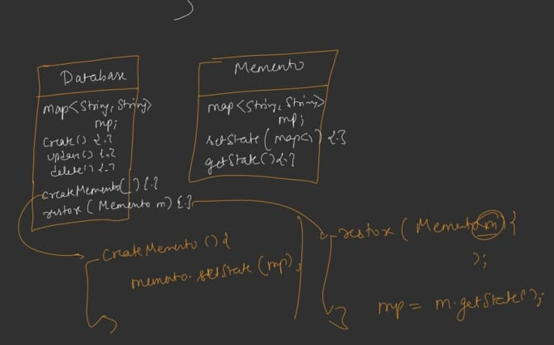
Let’s introduce Caretaker:-

4. Code Structure (Class Responsibilities)
A. Originator (Database Class)
- Holds the actual state (e.g., Map<String, String> records).
- Has CRUD methods: insert(), update(), remove().
- createMemento(): Creates a new DatabaseMemento object, passing its current records map to the Memento's constructor. Returns the Memento.
- restoreFromMemento(DatabaseMemento m): Calls m.getState() to retrieve the saved map and overwrites its own records with it.
- displayRecords(): Utility method to print the current state.
B. Memento (DatabaseMemento Class)
- Holds the state: Map<String, String> data.
- Constructor: Takes a Map<String, String> as input and stores it in this.data.
- getState(): Returns the stored data map.
- (Optionally a setState() method, but a constructor is sufficient.)
C. Caretaker (TransactionManager Class)
- Holds a reference to a DatabaseMemento backup (initialized to null).
- beginTransaction(Database db): If a backup already exists, delete it first. Then call db.createMemento() and store the returned Memento in backup.
- commitTransaction(): Delete the backup Memento and set it to null. The transaction is successful; no rollback needed.
- rollbackTransaction(Database db): If backup exists, call db.restoreFromMemento(backup). Then delete the backup and set it to null. If no backup exists, print "No backup available."
D. Client (Main Code)
- Creates a Database object and a TransactionManager object.
- Calls transactionManager.beginTransaction(db) → saves snapshot.
- Performs operations on db (insert, update, etc.).
- Calls db.displayRecords() to see current state.
- Depending on success/failure:
  - Calls transactionManager.commitTransaction() → discards backup.
  - Or calls transactionManager.rollbackTransaction(db) → restores previous state.
Code…see Notes

5. Standard UML Structure
- Originator
  - Has a state (e.g., a State object).
  - createMemento(): Returns a Memento.
  - restoreMemento(Memento m): Restores state from the Memento.
- Memento
  - Has a state (same type as Originator's state).
  - getState(): Returns the state.
  - setState(State s): Sets the state (or use a constructor).
- Caretaker
  - Has a reference (or a list) of Memento objects (e.g., List<Memento> history).
  - add(Originator o): Calls o.createMemento() and stores it.
  - undo(Originator o): Takes the last Memento and calls o.restoreMemento(m).
- Relationships:
  - Originator has-a Memento (creates it).
  - Caretaker has-a Memento (manages it).
  - Caretaker has-a Originator (to initiate save/restore).
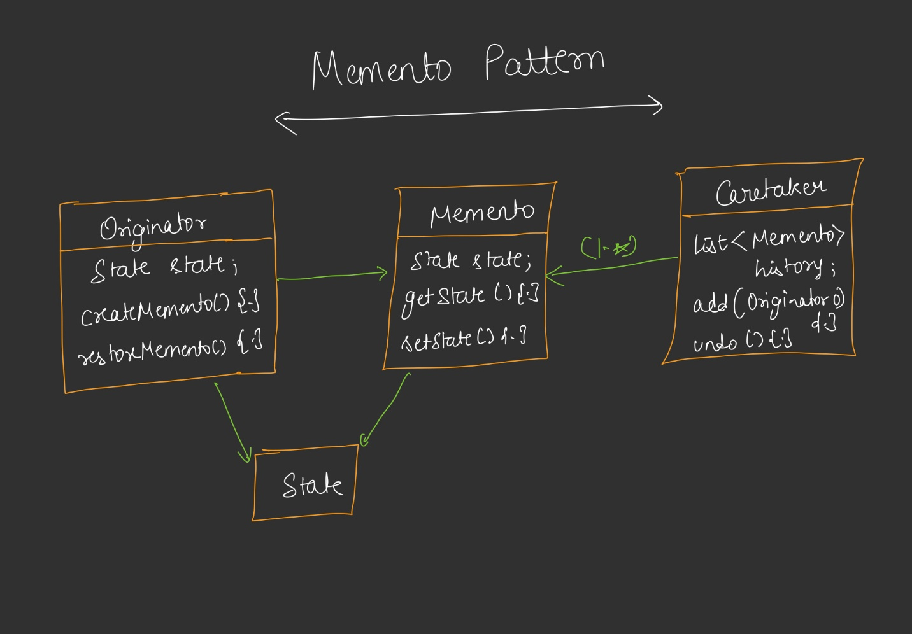

6. Standard Definition
The Memento Design Pattern provides the ability to take a snapshot of an object at various points in time and provides undo capabilities to a previous state without violating encapsulation.
- It separates the operation from the object it operates on by extracting the state-saving logic into a separate Memento object.

7. Real-World Use Cases
- Database Transaction Management: Commit and Rollback (as explained above).
- Git Version Control: Every commit is essentially a Memento. You can roll back to any previous commit (snapshot) if you make a mistake.
- Undo/Redo Functionality: Any application that supports undo (e.g., text editors, image editors) can use Mementos to save states before each action.
- Game Save/Load Systems: Saving the game state at checkpoints and reloading if the player fails.

8. Key Takeaways
- The Memento pattern is use-case specific and very practical when you need to save and restore object states.
- The Caretaker never knows the internal structure of the state — it only holds Memento objects. This preserves encapsulation.
- You can store a single Memento (for simple undo) or a list of Mementos (for multi-level undo/history).
- If you have a constructor that takes parameters and stores them in the current object, you are already creating a Memento — you just aren't using it in a formal pattern structure.
- The pattern is especially useful when you need atomicity — either all changes succeed or the object reverts to its original state.

